NAME :D DEVENDRA
REG NO :192525203
EXP:8
Query with Sub Query& Correlated Query
- Which of the students' scores are greater than the average score? (Subquery)
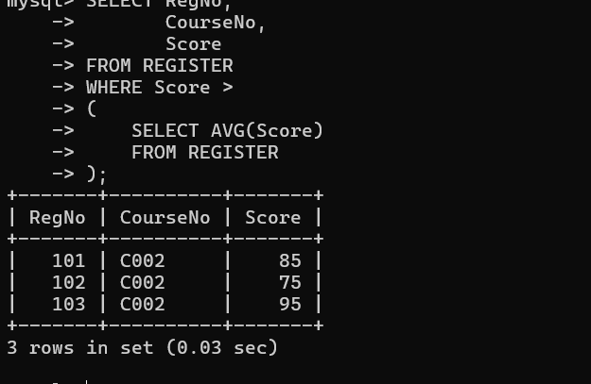

- Which students have written more than one assessment test? (Subquery)
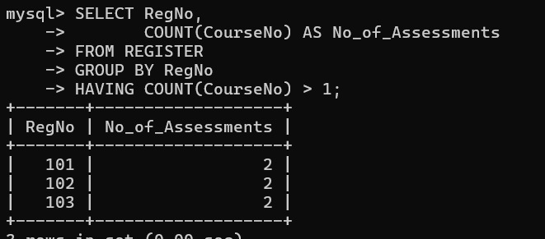

3.Which faculty joined most recently and when?
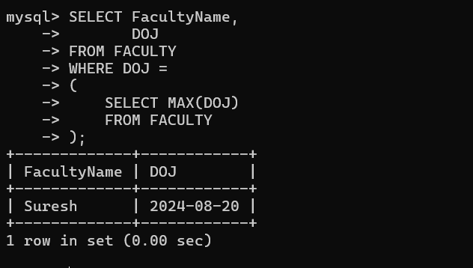
3 List the course and score of assessments that are greater than the average score of their course
